**AWS — Difference between Multi-AZ and Read Replicas in Amazon RDS**

[[](https://medium.com/@iamaashishpatel?source=post_page-----60fe848ef53a--------------------------------)](https://medium.com/@iamaashishpatel?source=post_page-----60fe848ef53a--------------------------------)

[[Awesome Cloud](https://medium.com/awesome-cloud?source=post_page-----60fe848ef53a--------------------------------)](https://medium.com/awesome-cloud?source=post_page-----60fe848ef53a--------------------------------)

[Ashish Patel](https://medium.com/@iamaashishpatel?source=post_page-----60fe848ef53a--------------------------------)

·

Follow

Published in

[Awesome Cloud](https://medium.com/awesome-cloud?source=post_page-----60fe848ef53a--------------------------------)

·

4 min read

·

Mar 15, 2020

462

5

Comparison: Amazon RDS Multi-AZ and Read Replicas.

**TL;DR:**

Amazon RDS Multi-AZ and Read Replicas maintain a copy of database but they are different in nature. Use Multi-AZ deployments for High Availability/Failover and Read Replicas for read scalability.

**Amazon RDS Multi-AZ**

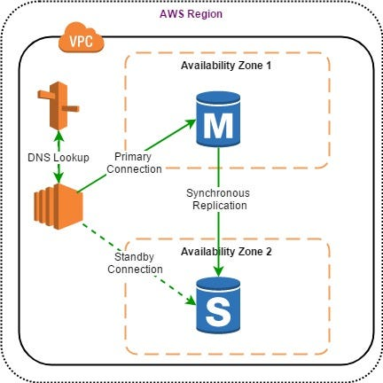

RDS Multi-AZ

[Amazon RDS Multi-AZ deployments](https://aws.amazon.com/rds/details/multi-az/) provide enhanced availability for database instances within a single AWS Region. With Multi-AZ, your data is synchronously replicated to a standby instance in a different AZ.

In the event of an infrastructure failure, Amazon RDS performs an automatic fail-over to the standby, minimizing disruption to your applications without administrative intervention.

**Benefits of Multi-AZ deployment:**

* Replication to a standby replica is synchronous which is highly durable.
* Endpoint of DB instance remains the same after a failover, the application can resume database operations without manual intervention.
* If a failure occurs, your availability impact is limited to time that automatic failover takes to complete. This helps to achieve increased availability.
* It reduces the impact of maintenance. RDS performs maintenance on the standby first, promotes the standby to primary master, and then performs maintenance on the old master which is now a standby replica.
* To prevent any negative impact of the backup process on performance, Amazon RDS creates a backup from the standby replica.
* When a problem is detected on the primary instance, it will automatically failover to the standby in the following conditions: 1) The primary DB instance fails. 2) An Availability Zone outage. 3) The DB instance server type is changed. 4) The operating system of DB instance is undergoing software patching. 5) Manual failover of DB instance was initiated using reboot with failover.

*Cross-region Multi-AZ is not currently supported yet.*

**Multi-AZ Use Cases**

* To get high availability, and enhance availability during planned system maintenance, and help protect databases against DB instance failure and Availability Zone disruption.
* To get data redundancy, eliminate I/O freezes, and minimize latency spikes during system backups.

**Amazon RDS Read Replicas**

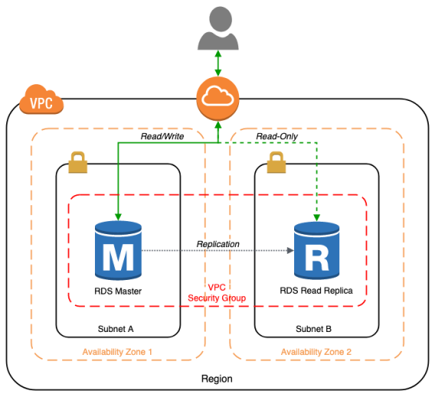

[Amazon RDS Read Replicas](https://aws.amazon.com/rds/details/read-replicas/) enable you to create one or more read-only copies of your database instance within the same AWS Region or in a different AWS Region to increase the scalability.

Updates made to source database are then asynchronously copied to Read Replicas. Writes can happen in main database only and reads can happen in Read replica database.

When you create a Read Replica, you first specify an existing DB instance as the source. Then Amazon RDS takes a snapshot of the source instance and creates a read-only instance from the snapshot. The source DB must have automatic backups enabled for setting up read replica.

**Benefits of Read Replicas**

* Read Replicas helps in decreasing load on the primary DB by serving read-only traffic.
* You can create Read Replicas within AZ, Cross-AZ or Cross-Region.
* Read Replica can be manually promoted as a standalone database instance.
* Read Replicas support Multi-AZ deployments.
* You can use Read Replicas to take logical backups, if you want to store the backups externally to RDS.
* You can have Read Replicas of Read Replicas.
* Read Replica helps to maintain a copy of databases in a different region for disaster recovery.
* You can have up to five Read Replicas per master, each with own DNS endpoint. Unlike a Multi-AZ standby replica, you can connect to each Read Replica and use them for read scaling.

**Read Replicas Use Cases**

* Business reporting or data warehousing scenarios where you might want business reporting queries to run against a read replica, rather than your production DB instance.
* Implementing disaster recovery. You can promote a read replica to a standalone instance as a disaster recovery solution if the primary DB instance fails.
* Scaling beyond the compute or I/O capacity of a single DB instance for read-heavy database workloads. You can direct this excess read traffic to one or more read replicas.
* Serving read traffic while the source DB instance is unavailable. In some cases, source DB instance might not be able to take I/O requests, for example due to I/O suspension for backups or scheduled maintenance. In these cases, you can direct read traffic to your read replicas.

*With RDS for MySQL, MariaDB, PostgreSQL, and Oracle, you can also set the read replica as Multi-AZ, allowing you to use the read replica as a DR target. When you promote the read replica to be a standalone database, it will already be Multi-AZ enabled.*

**Summary**

You can use Read Replicas with Multi-AZ as part of a disaster recovery (DR) strategy for your production databases. A well-designed and tested DR plan is critical for maintaining business continuity after a disaster. A Read Replica in a different region than the source database can be used as a standby database and promoted to become the new production database in case of a regional disruption.

***Important:****Multi-AZ deployments are not a read scaling solution, you cannot use a standby replica to serve read traffic. The standby is only there for failover.*